How to connect the AT8560 to generator：

1．Below is connecting drawing:



2. Below is multi-core with 5 pins plug which is accessory of AT8560

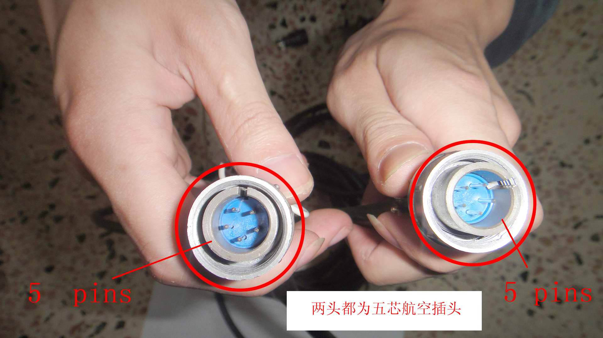

3.There are ATS socket on the panel of AT8560 and the generator

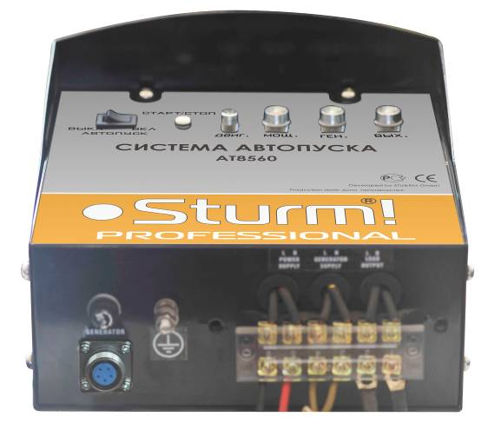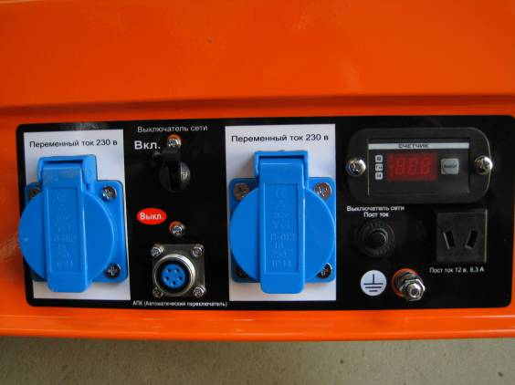

4. connect the AT8560 to the generator

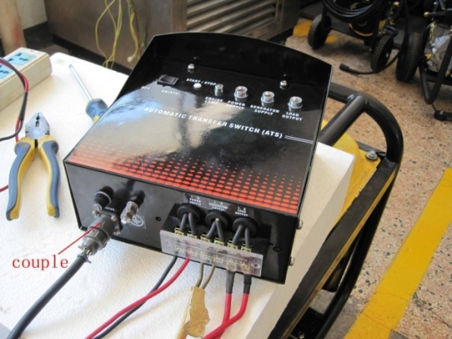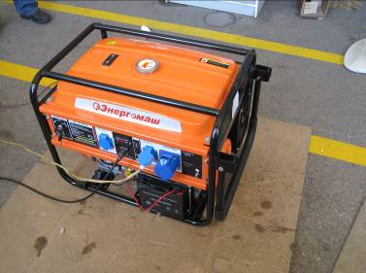

5．Connect generator output power to AT8560

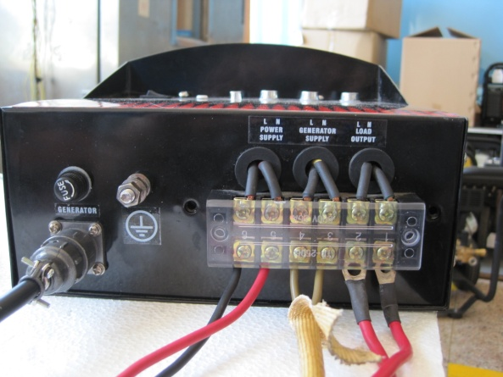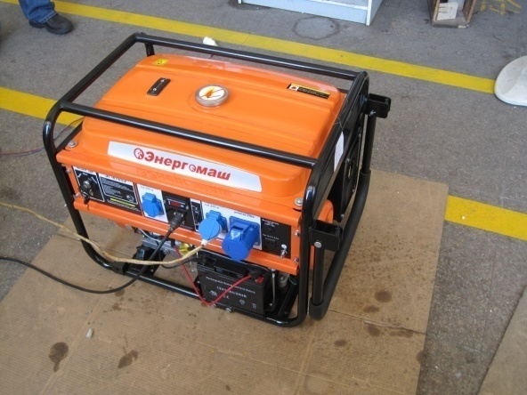

Connected with output load

Connected with AT8560